The purpose of this document is to provide re-work Instructions for the 200W DC/DC LLC Resonant Converter Reference Design (DM339011), to make it compatible with the latest ACMC and VMC software. A number of units have already been reworked but if the unit you have has not, these instructions will walk you through the necessary changes to use the new software. The rework includes removing the output filter and adjusting the current feedback circuit.
Step 1: Short the output inductor L4 by adding a thick copper wire which can carry ~17A continuous current across the component pads on the PCB. Figure 1 below shows a circuit equivalent while Figure 2 below shows the terminals to short on the PCB.

Figure 1: Updated Circuit with output inductor shorted

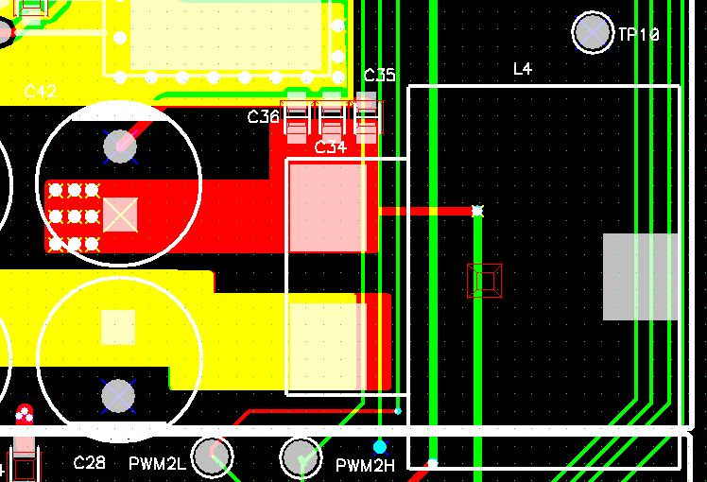
Figure 2: Location of Inductor L4 and Short Point

Step 2: Adjust the current feedback components R13, R11, and C11. Figure 3 below shows the three component locations in the circuit and Figure 4 below shows the PCB locations.

Figure 3: Updated circuit components highlighted

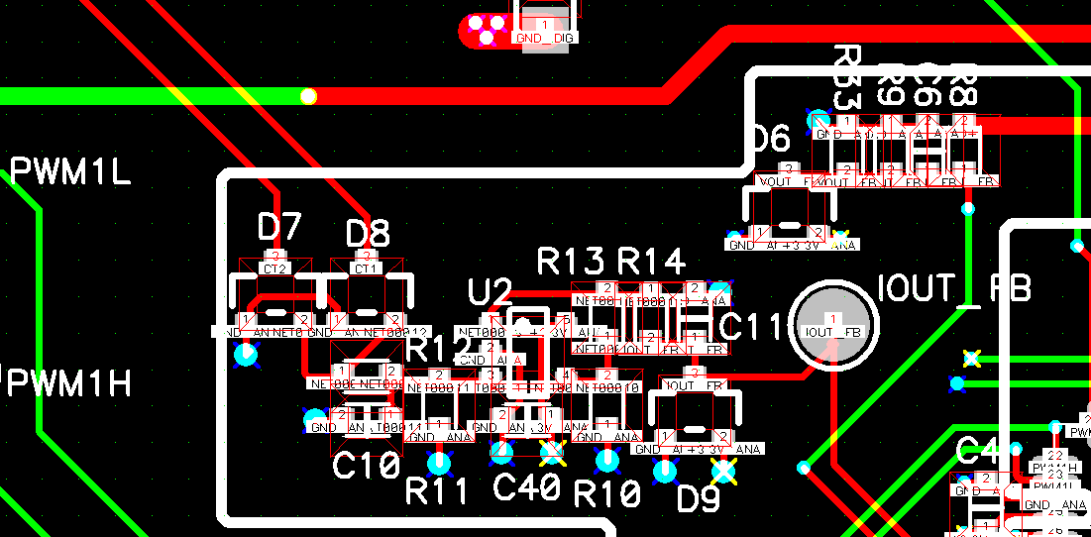
Figure 5: Location of current feedback components

The table below shows the new components chosen for C11, R13, and R11.
Step 3: Program the updated LLC Resonant Converter with the new ACMC or VMC software labeled without output filter.

